## horizontal line



Resume Analyzer - DB Project

Project Proposal

Submission: Sir Bilal Naeem

**─**

Musab Sarmad, 23L-5526

Talal Hashmi, 23L-5529

BFT-4B

# Resume Analyzer Proposal

## **Project Title: Resume Analyzer – Resume Evaluation System**

## **Project Overview:**

The Resume Analyzer is a Python-based application designed to **evaluate resumes against job descriptions** using **Natural Language Processing (NLP)**. It automates resume screening by extracting key skills, experience, and qualifications, then generating a **match score and recommendations** for improvement. The application features a **graphical user interface (GUI)** for ease of use and stores relevant data in an **SQL database**.

This project addresses the inefficiencies in **manual resume screening** and **Applicant Tracking System (ATS) rejections** by using AI to enhance **resume-job compatibility**.

## **Objectives:**

* Develop a **Python-only GUI application** to analyze resumes and job descriptions using NLP.
* Implement a **resume parser** to extract structured data from PDFs and DOCX files.
* Design an **AI-powered scoring system** based on keyword matching and experience relevance.
* Store **job descriptions, resumes, and scores** in an SQL database for structured analysis.
* Provide **real-time feedback and improvement suggestions** to job seekers.

## **Scope:**

### **Core Features:**

* **Resume Parsing** – Extract text and structured information from uploaded resumes.
* **Job Description Analysis** – Identify required skills and experience from job descriptions.
* **AI Resume Scoring** – Score resumes based on relevance to job descriptions.
* **Skill Gap Analysis** – Highlight missing skills and suggest improvements.
* **Graphical User Interface (GUI)** – Provide a user-friendly application experience.
* **Results & Report Generation** – Display insights in a detailed, readable format.

## **Target Audience:**

* **Job Seekers** – Individuals applying for jobs who want to optimize their resumes.
* **Recruiters** – HR professionals looking to automate initial resume screenings.
* **Career Services & Universities** – Career counselors assisting students with resume improvements.

## **Technology Stack:**

* **Backend:** Python
* **NLP:** spaCy, OpenAI API
* **Database:** SQLite / PostgreSQL
* **GUI Framework:** PyQt / Tkinter
* **File Handling:** PyMuPDF (PDF parsing), python-docx (DOCX support)
* **Authentication (if needed):** SQLite
* **Deployment:** Standalone Python application

## **Development Plan:**

### **📅 Phase 1: Research & Planning (Week 1)**

* Define **resume scoring methodology** (keyword matching, skill weightage).
* Select and configure **NLP models** for text analysis.
* Design **database schema** for job descriptions, resumes, and user data.

### **📅 Phase 2: Backend & AI Development (Week 2)**

* Implement **resume parser** (PDF/DOCX text extraction).
* Develop **job description analysis module** (extracting key skills & requirements).
* Implement **AI Resume Scoring** (comparing resumes with job descriptions).
* Store structured data in **SQL database**.

### **📅 Phase 3: GUI Development (Week 3)**

* Build **GUI using PyQt/Tkinter** for resume uploads & result visualization.
* Develop a **dashboard to display scores and feedback**.

### **📅 Phase 4: Testing & Deployment (Week 4)**

* Conduct **extensive testing** on different resume formats.
* Optimize **resume analysis accuracy** using real-world data.
* Package the system as a **standalone application**.

## **ERD (Entity-Relationship Diagram):**

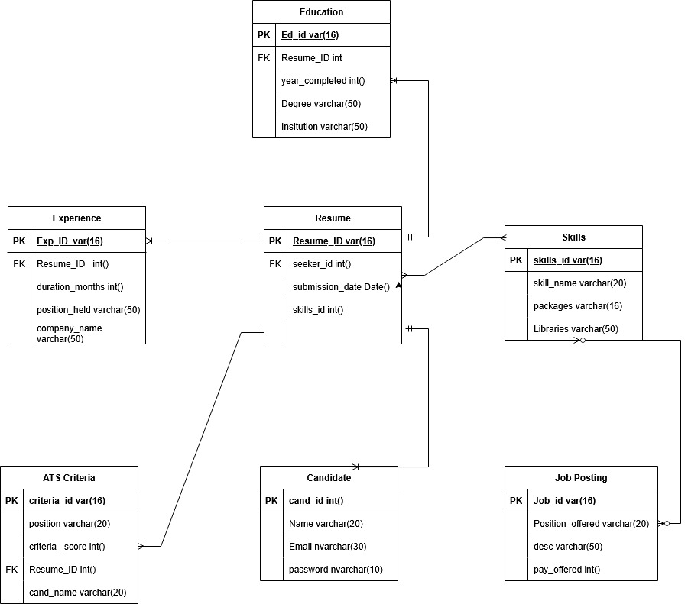

### 

### **Entities and Attributes**

#### **Candidate**

* **cand_id (Primary Key, int, Auto-increment)**
* **Name (varchar(20))**
* **Email (nvarchar(30), unique)**
* **Password (nvarchar(10))**

#### **Resume**

* **Resume_id (Primary Key, varchar(16))**
* **seeker_id (Foreign Key, references Candidate)**
* **submission_date (Date)**
* **skills_id (Foreign Key, references Skills)**

#### **Experience**

* **Exp_ID (Primary Key, varchar(16))**
* **Resume_ID (Foreign Key, references Resume)**
* **duration_months (int, not null)**
* **position_held (varchar(50))**
* **company_name (varchar(50))**

#### **Education**

* **Ed_id (Primary Key, varchar(16))**
* **Resume_ID (Foreign Key, references Resume)**
* **year_completed (int)**
* **Degree (varchar(50))**
* **Institution (varchar(50))**

#### **Skills**

* **skills_id (Primary Key, varchar(16))**
* **skill_name (varchar(20))**
* **packages (varchar(16))**
* **Libraries (varchar(50))**

#### **ATS Criteria**

* **criteria_id (Primary Key, varchar(16))**
* **position (varchar(20))**
* **criteria_score (int)**
* **Resume_ID (Foreign Key, references Resume)**
* **cand_name (varchar(20))**

#### **Job Posting**

* **Job_id (Primary Key, varchar(16))**
* **Position_offered (varchar(20))**
* **desc (varchar(50))**
* **pay_offered (int)**

### **Entity Relationships**

1. **Candidate → Resume (1:N)**
   * **A candidate can submit multiple resumes, but each resume belongs to only one candidate.**
2. **Resume → Experience (1:N)**
   * **A single resume can include multiple job experiences, but each experience entry is linked to only one resume.**
3. **Resume → Education (1:N)**
   * **A resume can contain multiple education records, but each education entry is associated with only one resume.**
4. **Resume → Skills (1:N)**
   * **A resume can list multiple skills, but each skill belongs to only one resume.**
5. **Resume → ATS Criteria (1:N)**
   * **A resume can be evaluated using multiple ATS criteria, but each ATS criteria entry is linked to only one resume.**
6. **Job Posting (Independent Entity)**
   * **Job postings do not directly connect to resumes in this model. However, resumes may be compared against job postings for evaluation purposes.**

### **Database Tables & Relationships**

1. Candidate Table **(Stores job seeker details)**
2. Resumes Table **(Stores uploaded resumes)**
3. Experience Table **(Stores past job experiences from resumes)**
4. Education Table **(Captures candidate qualifications)**
5. Skills Table **(Stores skills associated with resumes)**
6. ATS Criteria Table **(Stores applicant tracking system evaluation criteria)**
7. Job Postings Table **(Stores job listings)**

**This updated structure fully aligns with your provided diagram, ensuring efficient resume analysis and job matching.**

## **Conclusion:**

The **Resume Analyzer** provides an AI-driven solution for **job seekers** and **recruiters** to analyze resumes and job descriptions. Using **Python, NLP, and free resources**, this project will deliver an **accessible, scalable, and cost-effective** resume evaluation system. Future enhancements may include **cover letter analysis, interview preparation assistance, and real-time job matching**.